# How I learn Django

## Refrech python :

1. List package : pip list

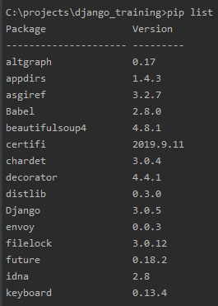

1. Get package detail : pip show beautifulsoup4

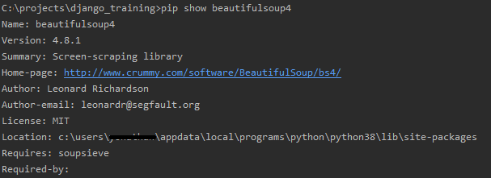

1. Install virtual environement : pip install virtualenv

* Create a virtual environment for a project :

cd project_folder

virtualenv venv

* Begin to use env in windows : env\Scripts\activate
* For stop : deactivate

## Create an install file : requirements.txt

'''

pip freeze > requirements.txt

'''

## Install all package :

'''

pip install -r requirements.txt

'''

## Create CI with Github :

1. After your first push with requirements.txt

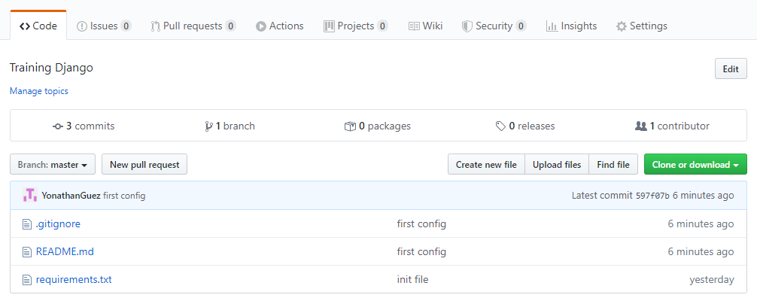

1. Go to Action :



Scroll down :

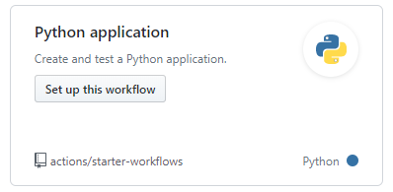

1. Set up this Workflow :

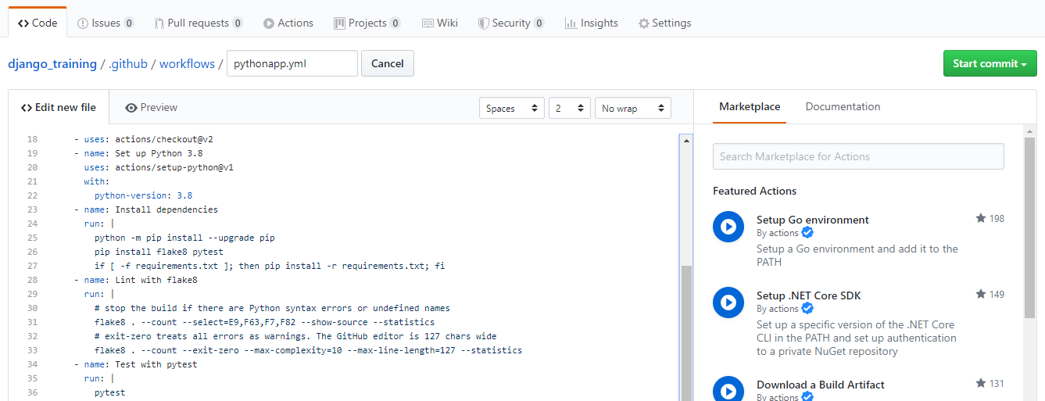

1. Start commit :

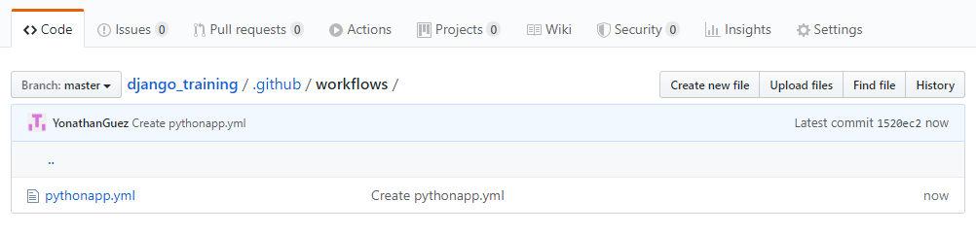

1. Go Back to the root :

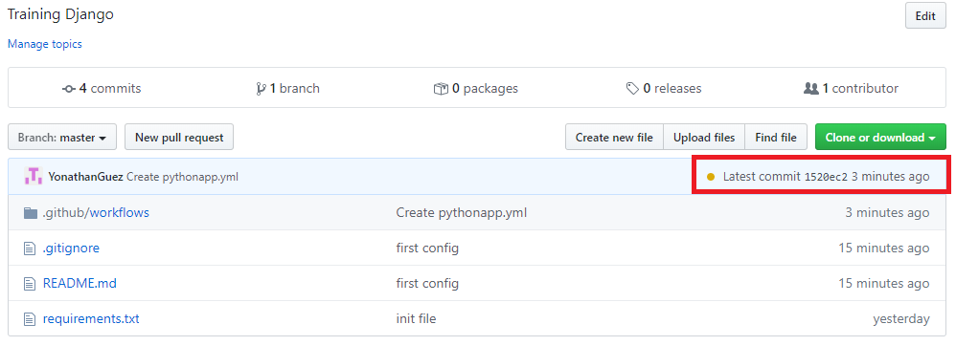

1. Click on Yellow button :

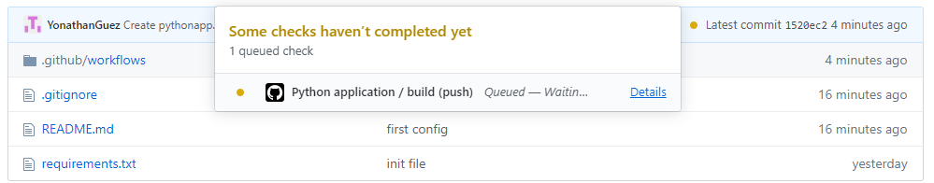

1. Click Detail :

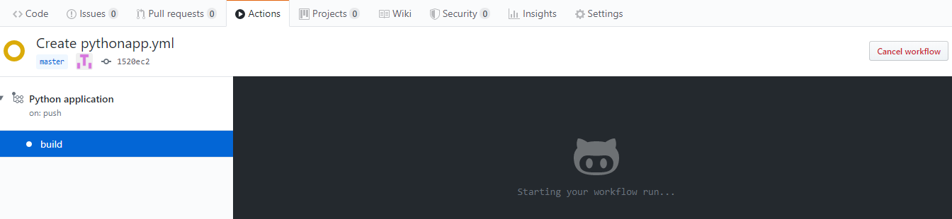

1. Wait for the result :

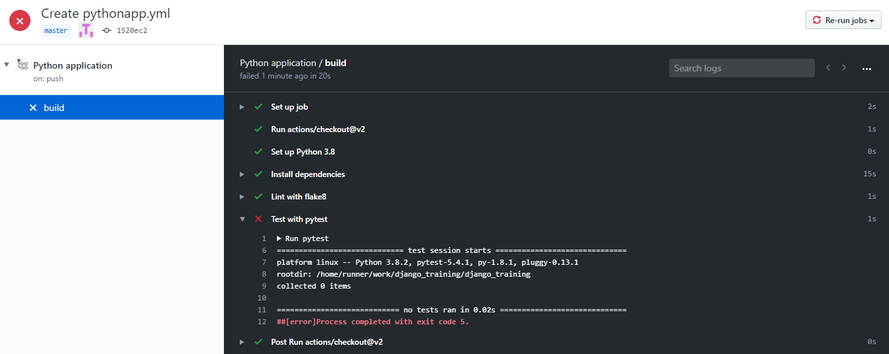

1. We have one error in the CI :

We will create test_pytest.py to the root :

def helloTest():  
 return "hello test"  
  
def test_pytest():  
 assert helloTest() == "hello test"

1. After the Push my CI run the Yml :

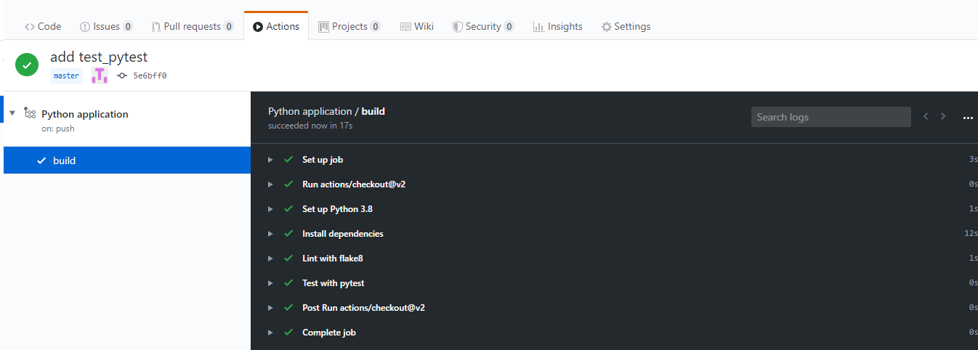

All it s green so it run my test_pytest.py

## 1) generate first admin

'''

django-admin startproject mysite

'''

That will create :

'''

mysite/

manage.py

mysite/

__init__.py

settings.py

urls.py

asgi.py

wsgi.py

'''

## 2) Check if it’s work

Enter in mysite: run the server

'''

py manage.py runserver

'''

## 3) Give the IP available

All available public IPs:

Listen on all available public IPs use: (0 is a shortcut for 0.0.0.0. )

'''

py manage.py runserver 0:8000

'''